“My first bioinformatics exploration using BLAST”

Aastha Mani
B.Tech. Biotechnology, Graphic Era University
Independent Learning Project

This document records my first self-initiated exploration of bioinformatics tools during my early undergraduate studies.

Abstract
Bioinformatics tools are widely applied in analyzing biological sequence data. In this study, the sequence of the BRCA1 gene of Homo sapiens was obtained from the National Center for Biotechnology Information database and analyzed using the BLAST tool. The nucleotide sequence of the BRCA1 gene was obtained in FASTA format and analyzed using the BLAST nucleotide search tool. Several sequences showing high similarity to the query sequence were obtained, with the top alignment showing 100% sequence identity to the Homo sapiens BRCA1 transcript variant. These results show that BLAST can be applied in comparative genomics and biological sequence analysis.

Introduction
Bioinformatics is a scientific discipline that combines the fields of biology, computer science, and information technology. Bioinformatics plays a vital role in the analysis of biological data. One of the most important tasks in bioinformatics is the comparison of DNA sequences, as it provides information about the similarities and differences between biological species.
Sequence alignment tools are very useful for identifying homologous genes and the biological functions of the genes. The Basic Local Alignment Search Tool (BLAST) is the most popular tool for sequence alignment. BLAST is a tool that allows users to search for similarities between a given sequence and the sequences in a biological database.
The BRCA1 gene is a very important gene that plays a vital role in the repair of DNA damage. The mutation of the BRCA1 gene has a high risk of breast and ovarian cancer. In the current study, the sequence of the BRCA1 gene was analyzed using the BLAST tool for sequence similarity.

Learning Objective
The purpose of this study was to gain hands-on familiarity with the commonly used bioinformatics databases. This study was conducted by a second-semester undergraduate student of biotechnology, and the exercise was performed mainly as a learning activity to grasp the concept of DNA sequence comparison.

Materials and Methods
The nucleotide sequence utilized in this study was obtained from the National Center for Biotechnology Information gene database. The BRCA1 gene from Homo sapiens was used as the query sequence.
The sequence was utilized as input for the BLAST tool. The nucleotide sequence was analyzed by using the nucleotide BLAST tool, also known as BLASTN. The standard nucleotide database, also known as core_nt, was utilized as the database for the BLAST tool.
In BLAST, the entered sequence is compared with the existing sequences in the database, and results are provided based on similarities. Results are analyzed based on score, percentage, coverage, and E-value. Graphical representation and sequence alignment are also used for better understanding of the results.

Workflow of the Analysis
- Search for the BRCA1 gene in the NCBI database
- Retrieve the nucleotide sequence in FASTA format
- Submit the sequence to BLAST
- Analyze alignment results including percent identity, query coverage, and graphical summary.
- Document screenshots and observations

Results
The BLAST output provides several parameters including alignment score, percent identity, query coverage, and E-value, which are used to evaluate sequence similarity. The BLAST search results revealed multiple sequences that had significant similarity with the query sequence for BRCA1. The best match was for the Homo sapiens BRCA1 transcript variant 1, which had 100% sequence identity and full coverage of the query sequence.
The graphical summary of BLAST results revealed that there was strong alignment across the full length of the query sequence. The pairwise alignment showed several regions with exact nucleotide matches between the query and subject sequences.
These results revealed that the sequence for the BRCA1 gene is highly conserved across different transcript variants in humans.
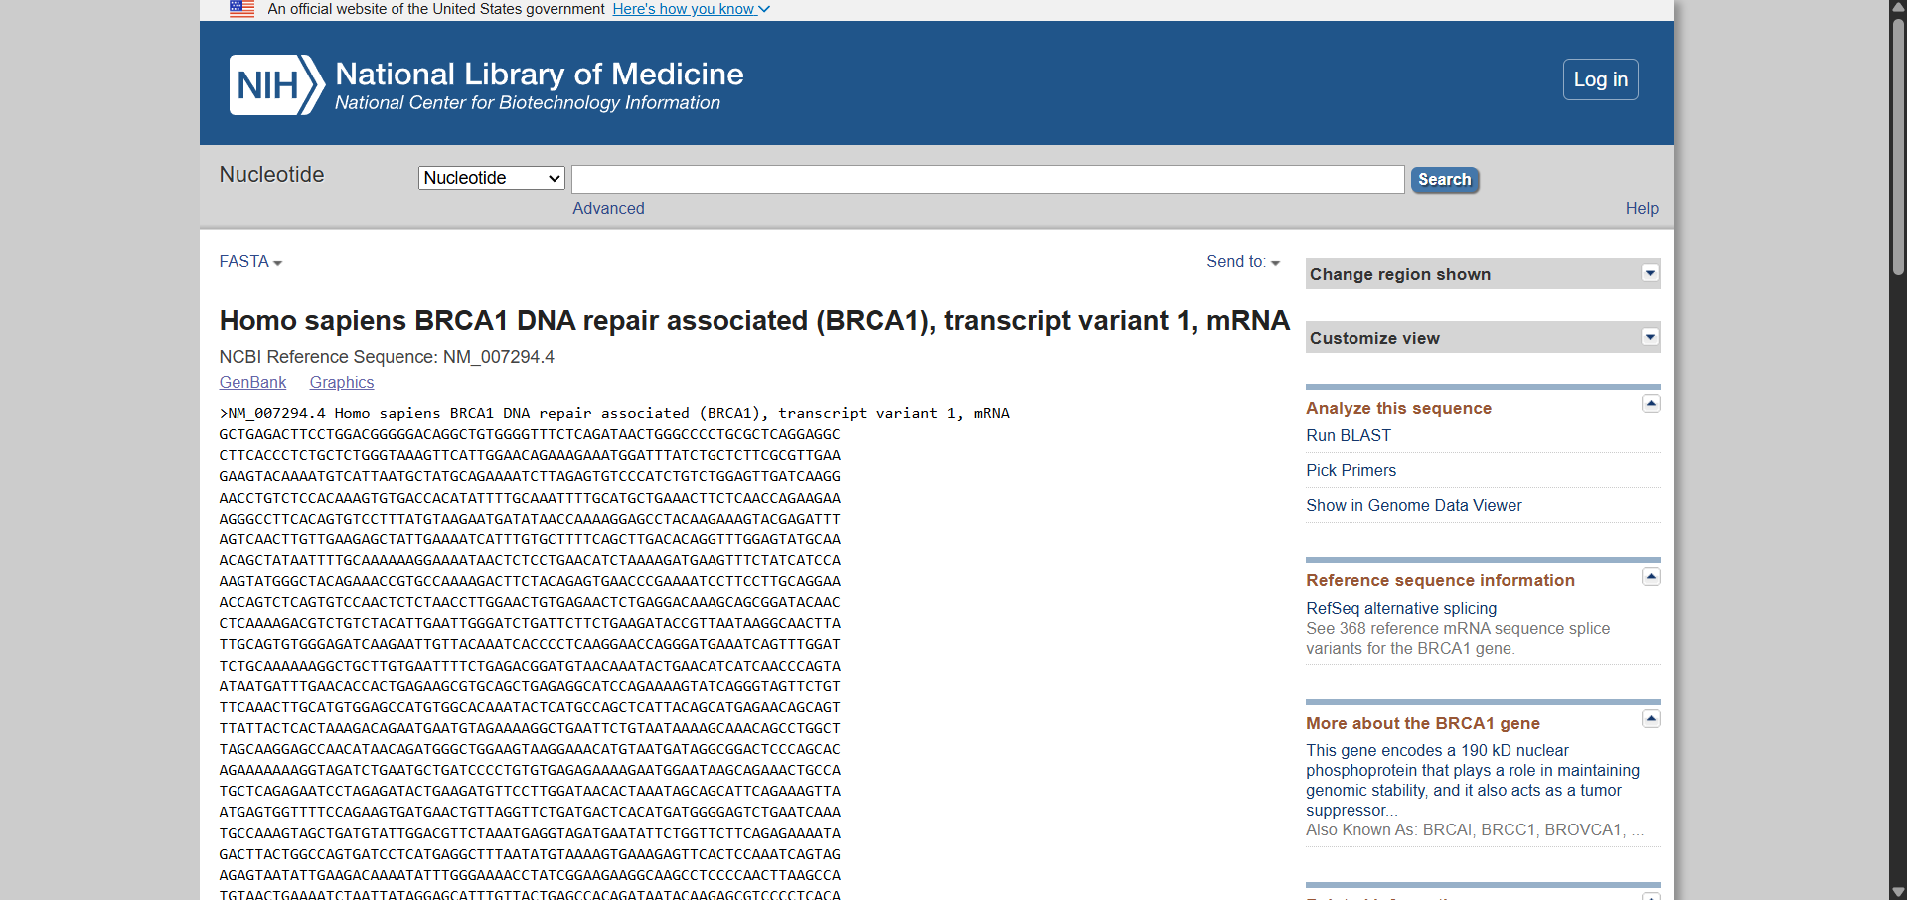
Data Source (NCBI Gene Page)

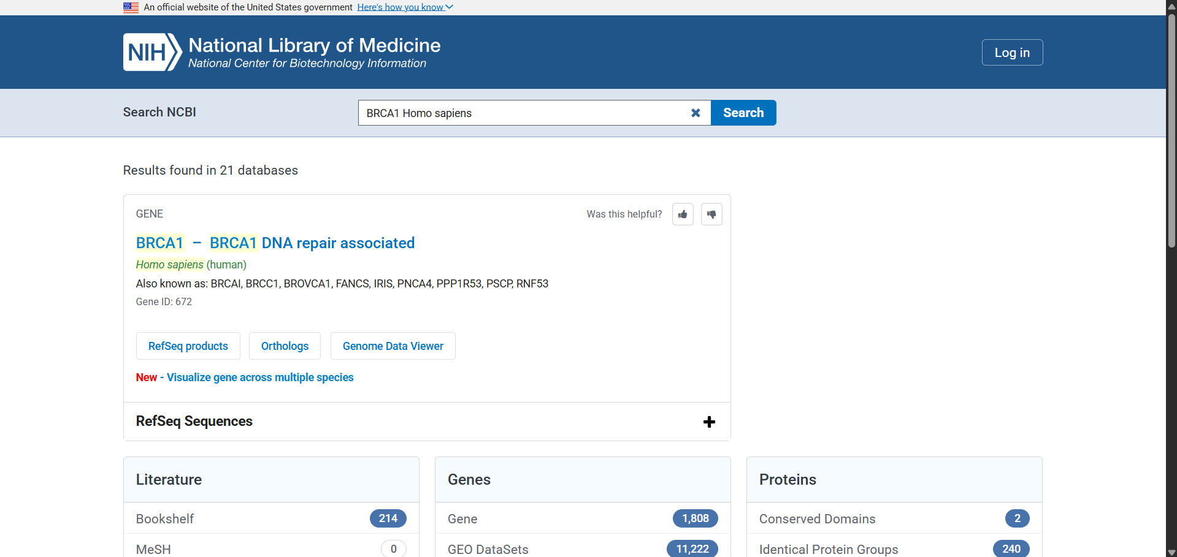
Gene Search Results

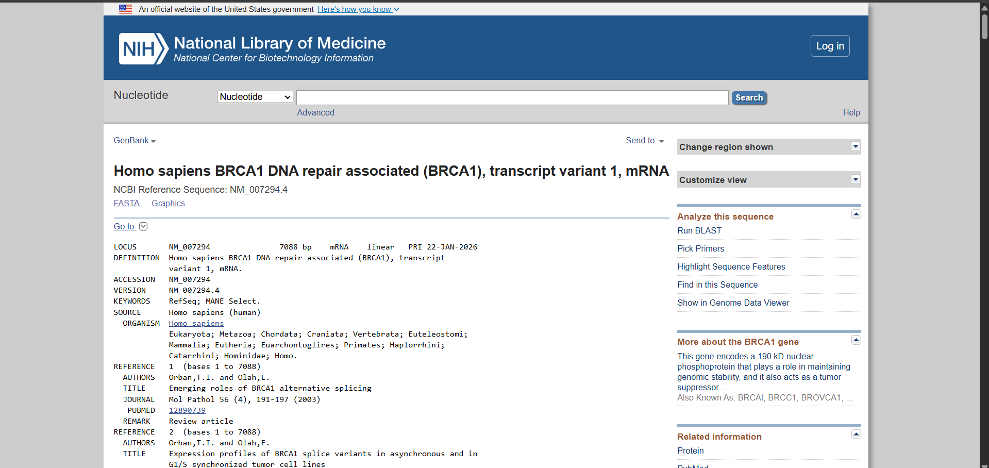
FASTA Sequence

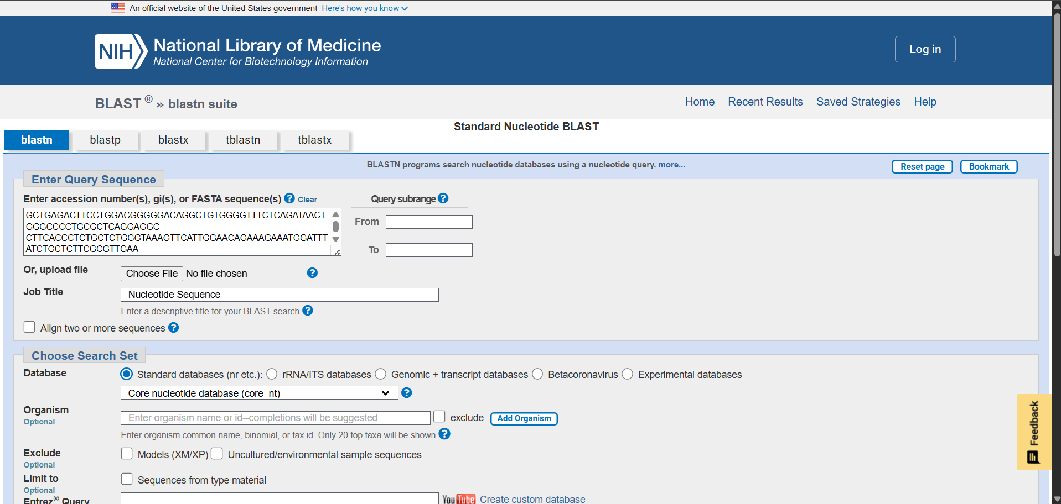
BLAST Query Input
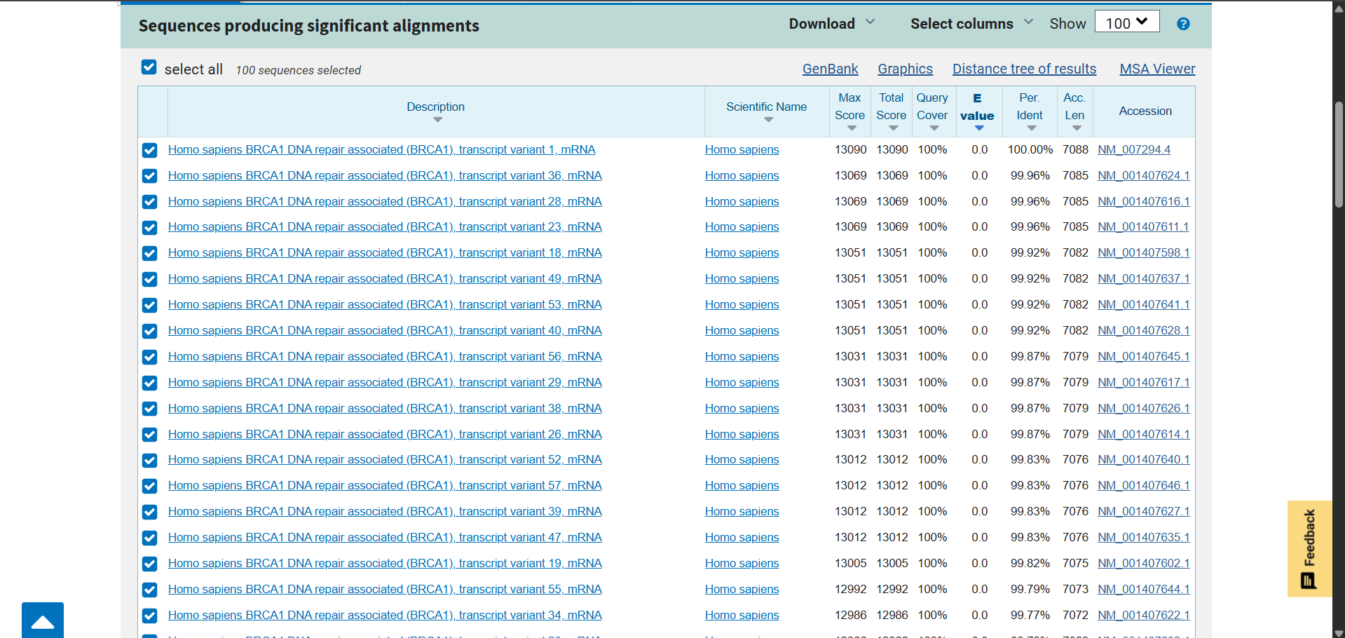
BLAST Results Table

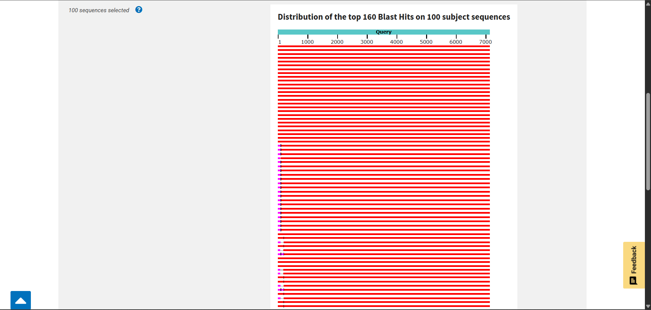
Graphical Summary
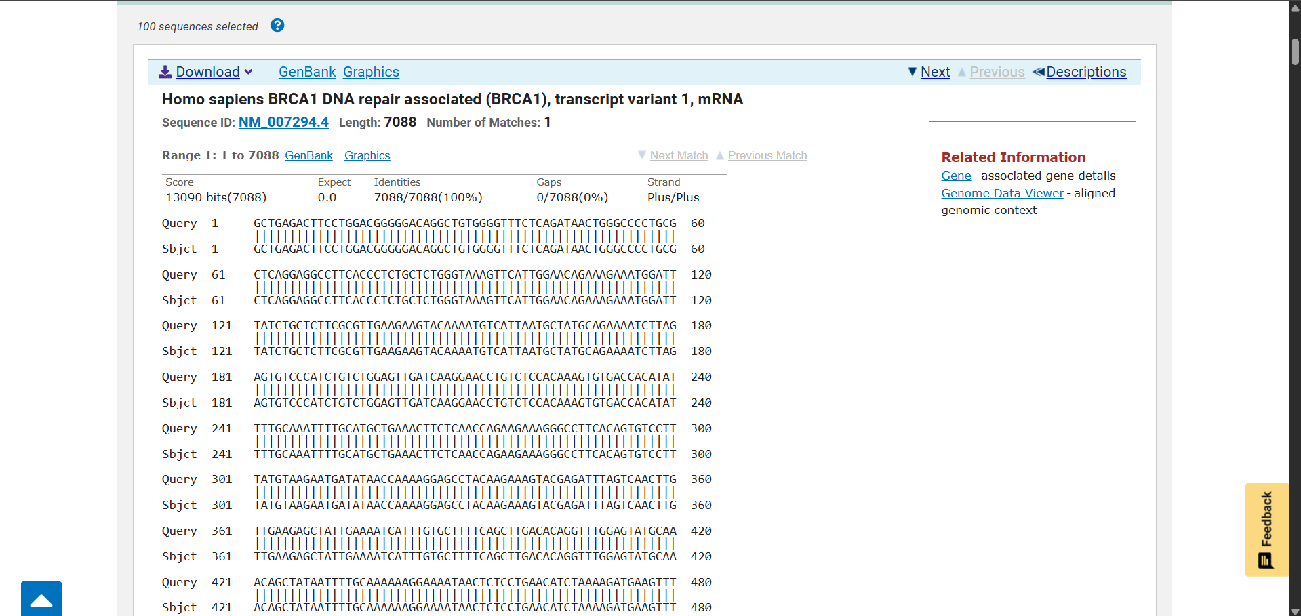
Pairwise Sequence Alignment

Discussion
The results obtained from the BLAST analysis clearly show that sequence alignment tools are effective in identifying homologous DNA sequences. A high percentage of identity between the sequence and other BRCA1 transcript variants obtained from the database clearly indicates that the sequence obtained from the database is accurate.
The sequence conservation obtained from the results of sequence alignment indicates that the BRCA1 gene plays a crucial role in maintaining genomic stability. The results obtained from sequence alignment also show that bioinformatics tools are effective in biological research, allowing biological data to be compared easily.
Bioinformatics tools like BLAST are often applied in genomics, evolutionary, and medical research to analyze biological data.

Limitations of the Study
Although the BLAST analysis provided useful insights into the similarity of the BRCA1 gene sequence, this study has several limitations. Firstly, this study was based on sequence comparison, which was conducted by using BLAST. Although this tool can identify regions of local similarity between sequences, a detailed analysis of the function of the gene or structure of the proteins was not conducted in this study.
Secondly, this study was based on publicly available data, which was obtained from the National Center for Biotechnology Information database. Even though these databases are very reliable, experimental validation of results was not conducted. Thus, results are based entirely on computational analysis.
Although this study was based on a limited approach, more research can be conducted by using various tools to validate results.

Future Scope
The results obtained from this study demonstrate the usefulness of BLAST for DNA sequence comparison and genomic analysis. Future research could expand this analysis by comparing BRCA1 sequences across different species to study evolutionary relationships and genetic conservation.
Further research can also include analyzing DNA sequences by performing multiple sequence alignments using advanced tools like Clustal Omega. Structural analysis of the BRCA1 protein can also be included by using various databases that provide information about protein structures.
Further research can also include using various machine learning techniques and advanced bioinformatics tools to predict mutations and their possible impact on genes.

Conclusion
This study illustrates the practical application of the BLAST tool in DNA sequence comparison. In this study, the DNA sequence of the BRCA1 gene downloaded from the NCBI online database was subjected to analysis using the BLAST tool. This showed high similarity in the DNA sequence with other transcript variants of the gene, validating the gene’s conservation.
This study illustrates the importance of bioinformatics tools in modern biological studies and offers an understanding of the practical application of DNA sequence alignment.
This exploration provided an introductory understanding of how computational tools are used to analyze genetic sequences and highlighted the importance of bioinformatics in modern biological research.

References
- Altschul SF et al. Basic Local Alignment Search Tool (BLAST)
- National Center for Biotechnology Information Database
- Mount DW. Bioinformatics: Sequence and Genome Analysis
- National Institutes of Health – NCBI Resources

